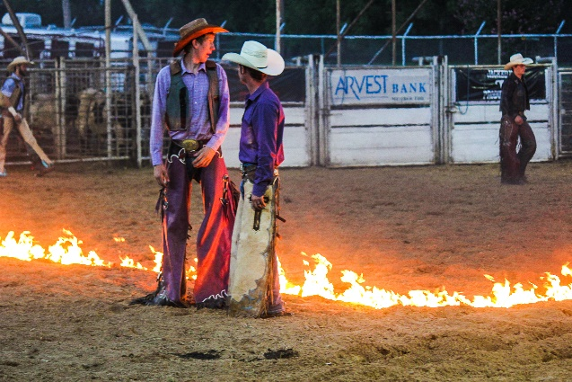
Sebastian County Fair
August 21 – 28, 2021

Fair Schedule

Saturday August 14 Mandatory Poultry Testing.
7:00 A—12:00 PM Sebastian County Fairgrounds,
Greenwood, AR
Saturday, August 21
10:00 AM - 2:00 PM Creative Arts Early Entry
3:00 PM Interviews Talent Show/Pageant
Monday, August 23
1:00 PM - 7:00 PM Creative Arts Entries in Place
3:00 PM—5:30 PM Exhibitor check in—Entries in place Barn
5:00 PM Concession setup
Request all livestock equipment in place
6:00 PM—8:00 PM Commercial Bldg setup
7:00 PM Request all livestock equipment in place

Tuesday, August 24- Gate and Rides DOLLAR NIGHT!!!!
9:00 AM Creative Arts Judging - Building Closed
1:00 PM - 7:00 PM Livestock Entries in place
5:00 PM - 7:00 PM Livestock Check In (Office)
5:00 PM Gate Open
5:00 PM Creative Arts Open
5:00 PM Carnival Opens
5:00 PM Commercial Exhibits in place
7:00 PM Mandatory Livestock Exhibitor Meeting
7:30 PM Animal Weigh In (following exhibitor meeting)
9:00 PM Creative Arts and Commercial Bldg Closes
Wednesday, August 25
8:00 AM Swine Judging, followed by Sheep,
8:00 AM—4:00 PM Pullet Chain, Poultry, and Rabbit checkin
11:30 AM Meal for exhibitors sponsored by Farm Credit
1:00 PM Goats, Dairy, Breeding Beef, and Steer Judging
4:30 PM Mandatory Pullet Chain, Poultry, and Rabbit
exhibitor meeting
5:00 PM Pullet Chain, Poultry, and Rabbit Judging
5:00 PM Gate Starts - $3 Adult, $2 Children (6-12 yr)
5:00 PM Creative Arts Opens
5:00 PM Commercial Bldg Opens
5:00 PM Carnival Opens
5:00 PM Skill-A-Thon & Showmanship—Rabbit &
Poultry

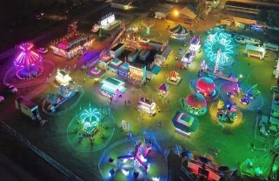
DAN THE PIRATE MAN! JOHNSON BROS. CARNIVAL

Thursday, August 26 9:00 AM—12:00 PM School Day
5:00 PM Gate Starts - $5 Adult, $3 Children
(6-12 yr)
5:00 PM Creative Arts Bldg Opens
5:00 PM Commercial Bldg Opens
5:00 PM Carnival Opens
6:30 PM Livestock Awards
6:30 PM Hay Show/ tickets for cattle drop
available
8:00 PM Cow Patty Drop

Friday, August 27 9:00 AM — 12:00 PM School Day
5:00 PM Gate Starts - $5 Adult, $3 Children
(6-12 yr)
5:00 PM Carnival Opens
5:00 PM Creative Arts Building Opens
5:00 PM Commercial Building Opens
8:00 PM Bull Riding

Saturday, August 28 Senior Day
12:00 PM Gate Starts. $5 Adults, $3 Child. 1-4 & 6-
Close Armbands
1:30 PM—2:30 PM Power Wheels Racing
2:00 PM Bingo
4:00 PM Pre-Auction Premium Dinner
5:00 PM Junior Livestock Auction
8:00 PM Livestock Barn Clean Out Begins
9:00 PM Livestock Release According to Superintendents

Sunday, August 29 - 2:00 PM -? - Clean-Up
2:00 PM - 4:00 PM Commercial Building Exhibits Pickup & Released

Monday, August 30
3:00 PM - 7:00 PM Creative Arts Exhibits Released

CARNIVAL OPEN NIGHTLY - ARM BANDS AVAILABLE

